44-560 ADVANCED TOPICS IN DB SYSTEMS  
Assignment – 02

Name : Vasanth Sai Aitha

SID : S571903

1. Creating all tables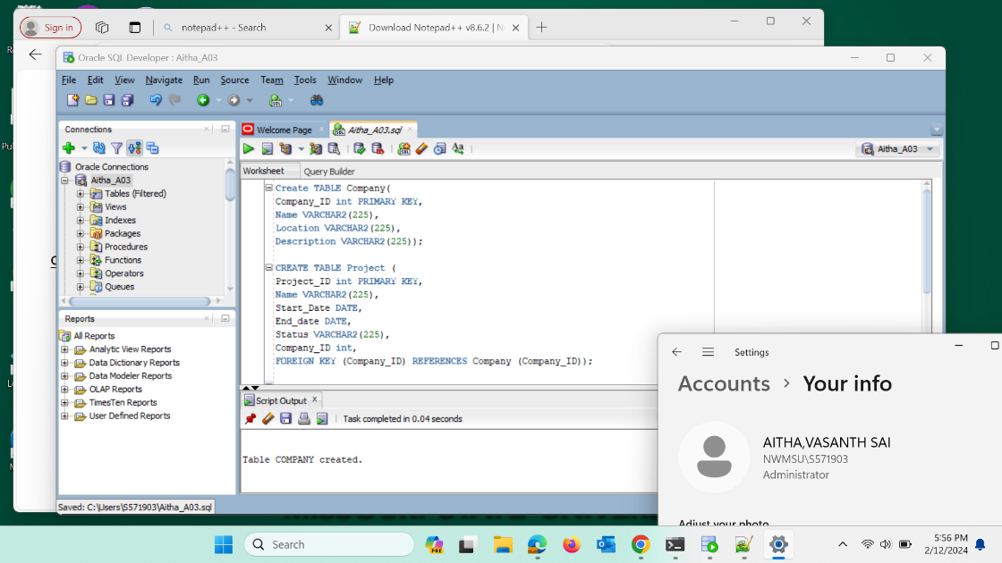

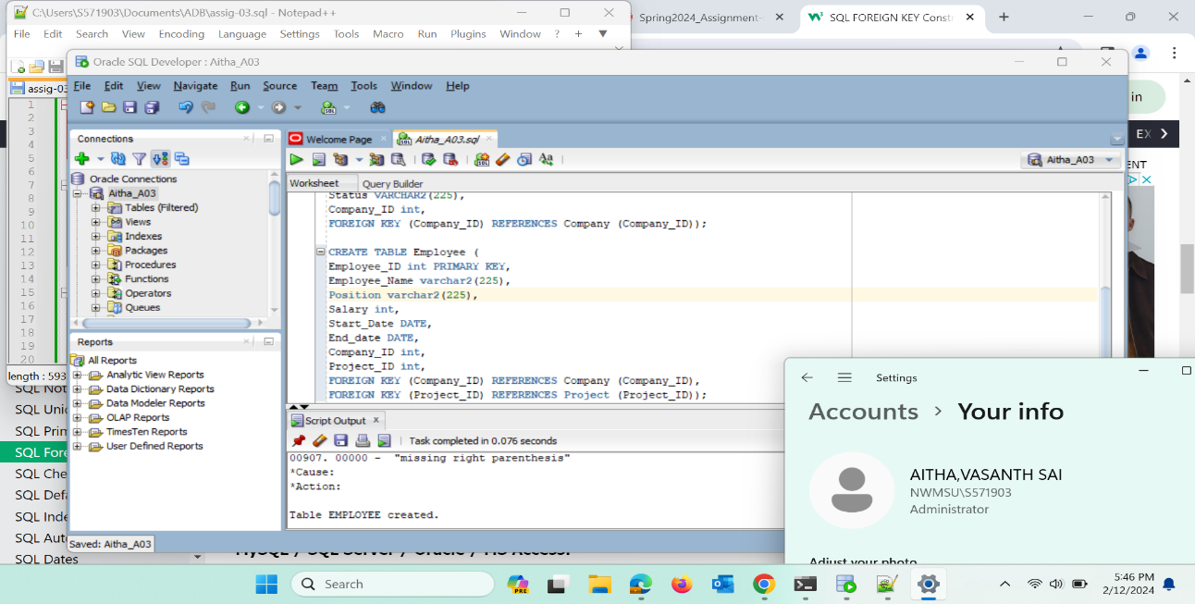

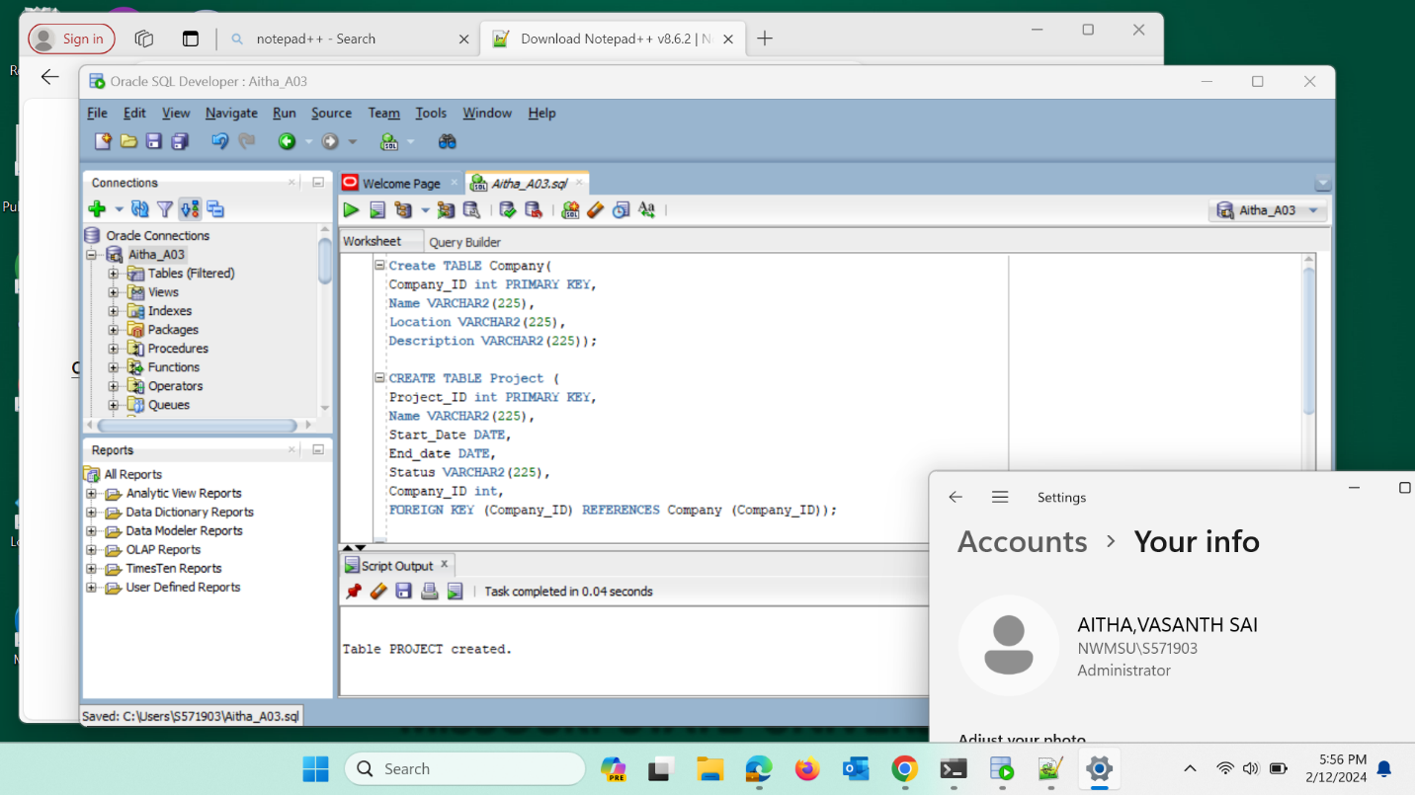

2. Insert at least 5 records into each table with real-time data.

3Alter the Employee table by adding a new column of your wish.

4. Update the Company Location of any of the records.

5. Retrieve all employees with their project information (Use joins)

6. Retrieve all employees and their respective project and company details.

7. Display the total number of employees in the project (think about GROUP BY).

8. Find the average salary of employees in each company.

10. Display the details of the employee who has the 2nd highest salary.

11. Commit the Database.

12. Drop all tables in the Database; Write a comment in your SQL file to answer the question  
(Explain the order you deleted the tables and why).

--1st i am droping the Employee table because there are no tables that containg foreign keys from the Employee table

--2nd i am deleting the project table becouse after deleting the Employee table there is no other table using its primiry as its foreign. we cant delete Company table now because its primary key acts as foregin key in project table

-- At last we delete the Company table as all the tables containg its primary key as foreign key are dropped.

-- ROLLBACK takes us to the place where the last COMMENT as taken place. once after roll back if we and run select statement we get error that table or view does not exist

13. Roll back the database and display all the tables (Explain the output).

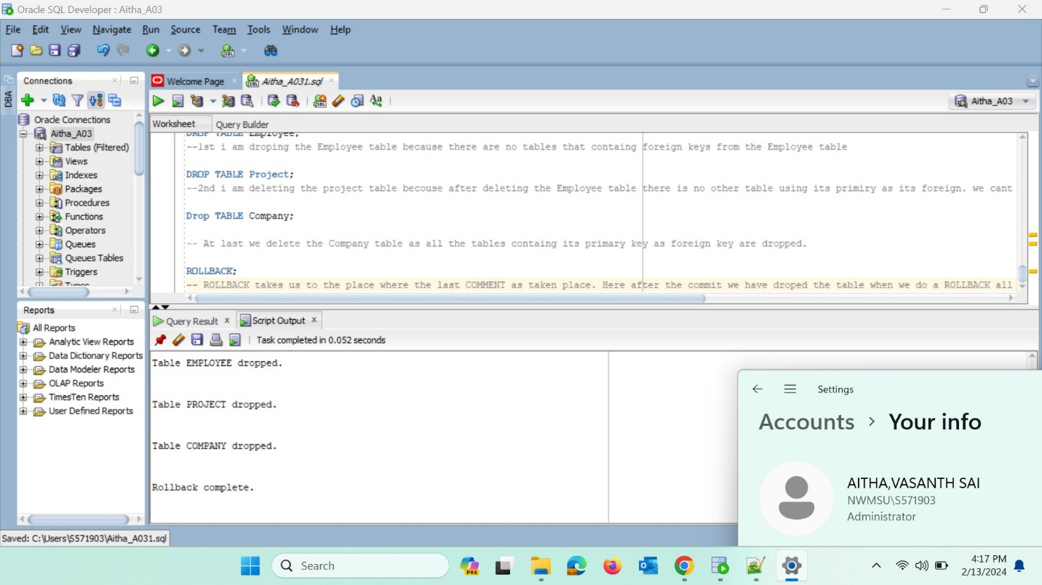

14. What is the difference between varchar and varchar2?

--VARCHAR can store up to 2000 bytes of characters while VARCHAR2 can store up to 4000 bytes of characters.

15. What is the difference between drop, truncate, and delete? Put your answer as a comment  
in the SQL file.

--The DROP command in SQL removes the table from the database, the DELETE command removes one or more records from the table, and the TRUNCATE command removes all the rows from the existing table.

16. What are the different aggregate functions we have specified? Put your answer as a  
comment in the SQL file.

-- The aggregate functions that we have used in the assignment are count, AVG and MAX The COUNT() function returns the number of rows that matches a specified criterion.

--The AVG() function returns the average value of a numeric column.

--The MAX() function returns the largest value of the selected column.